Nicholas Marshal

Dr. Nelbert St. Clair

ITEC 4341

September 3, 2018

Lab 2

Pacman Pcap

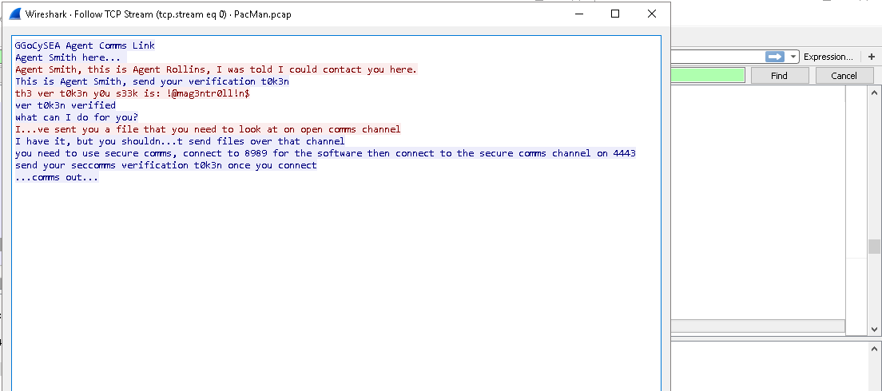

This was the first t0k3n that I found in the file by following the first stream. First t0k3n: **!@mag3ntr0ll!n$**

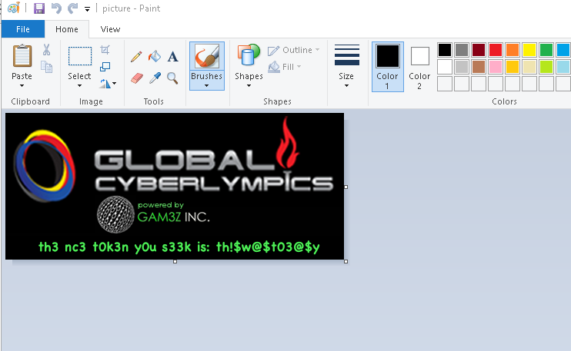

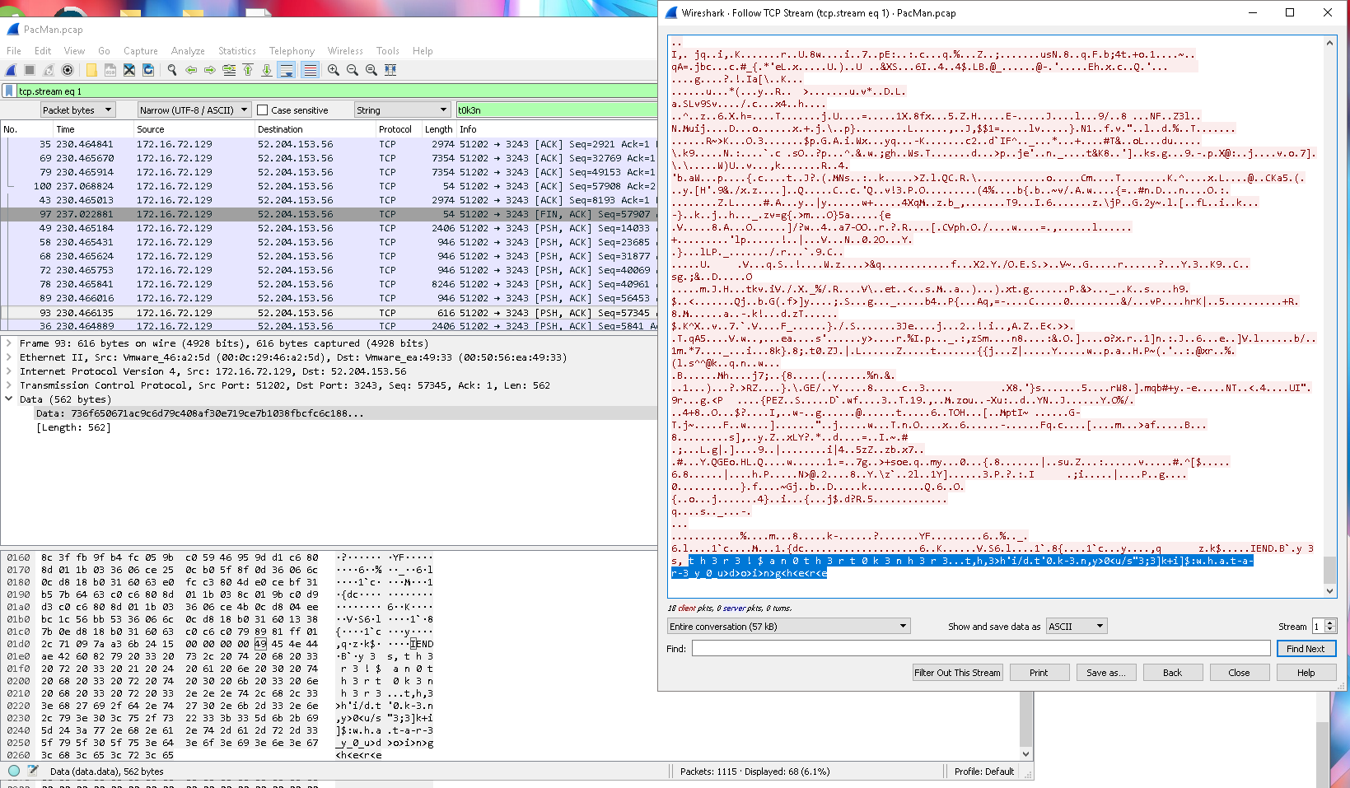

The second and third t0k3n’s were found in the same stream. The first is the png file that has the t0k3n: **th!$w@$t03@$y** . The second t0k3n we received is: **whatare3youdoinghere** . Which is in the coding before creating the png giving the previous t0k3n.

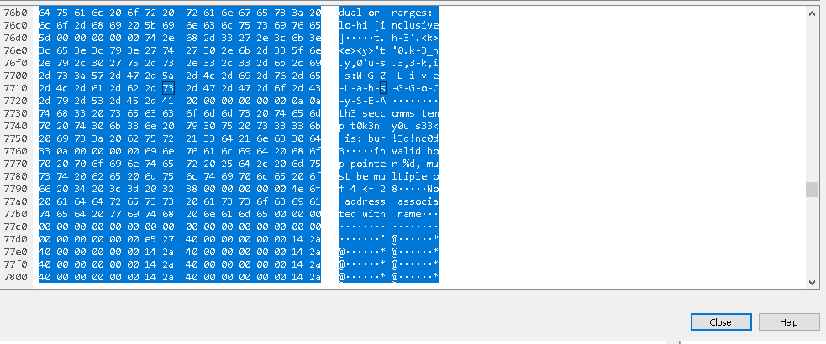

The fourth and fifth t0k3n are found together in the same packet which is number 764. When looking at the details of the packet after doing a filter search the 2 t0k3ns are found. Fouth t0k3n: **WGZLiveLabsGGoCySEA** . Fifth t0k3n: **bur!3d!nc0d3**

**Crew89op2x pcap**

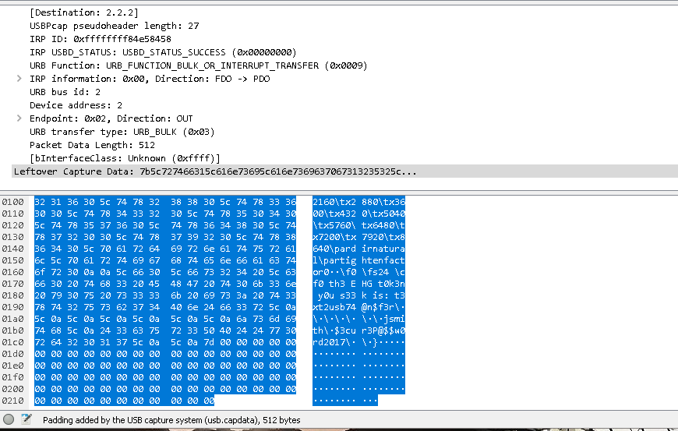

This token was found with doing a simple search for the keyword t0k3n. Sixth t0k3n: **t3xt2usb74@n$f3r**

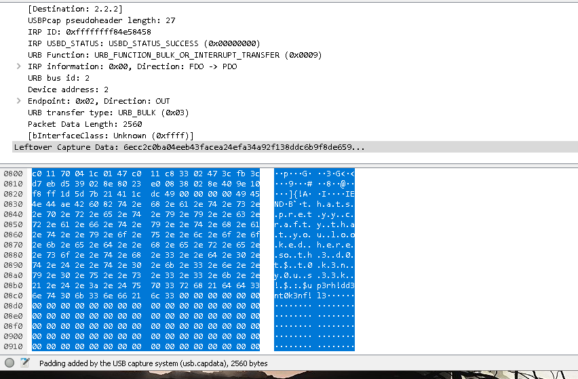

This is the seventh t0k3n that was hidden in packet 891 still using the quick search method to milk all the t0k3ns it could find. Seventh t0k3n: **$up3rh!dd3ntt0k3nf!l3**

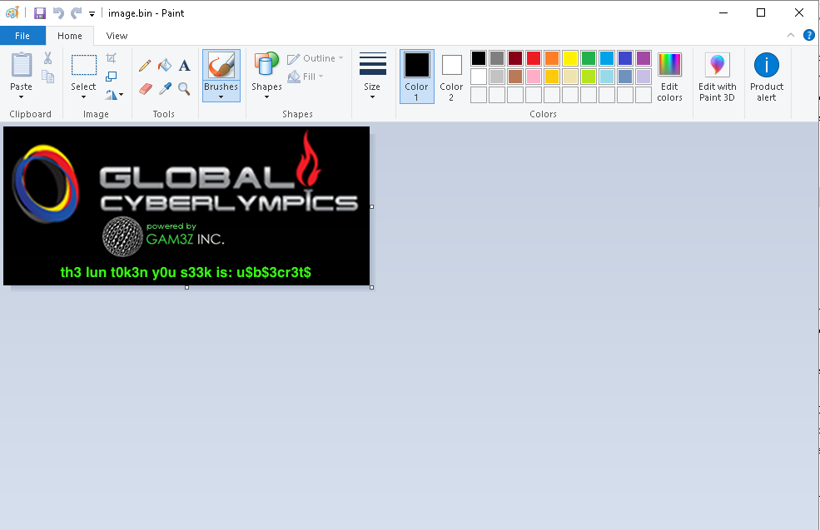

This was the finaly t0k3n that I found and the reason it got my attention was that in the details of the packet it has t0k3n in the description along with png at the top so, I figured with that along with the size being over 50,000 it was an image. This is when I exported the raw data into a bin file and opened it with Paint to where I found the eighth t0k3n. Eighth t0k3n: **u$b$3cr3t$ .**

In total I found **8 t0k3ns** within both pcap files.